Health feature:

1.ECG

2.EKG

3.SpO2

4.Temerature

5.GSR

Pending

1.Blood pressure

2.glucose

3. spirometer

# 1.EMG/EKG Shield for Arduino

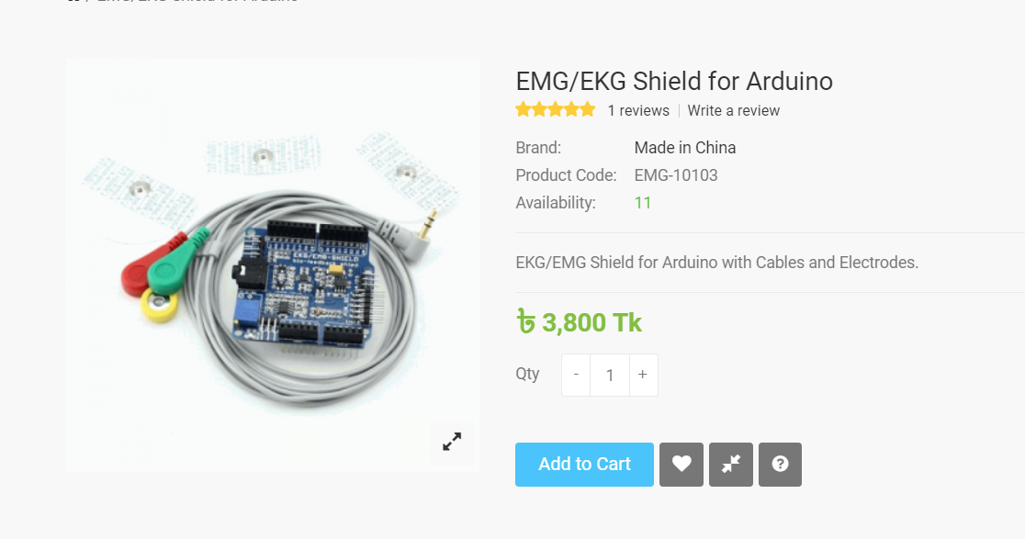

Links:

<https://bdspeedytech.com/index.php?route=product/product&product_id=3017>

<https://udvabony.com/product/emg-ekg-shield-for-arduino/>

# 2. **Finger oximeter heart rate**

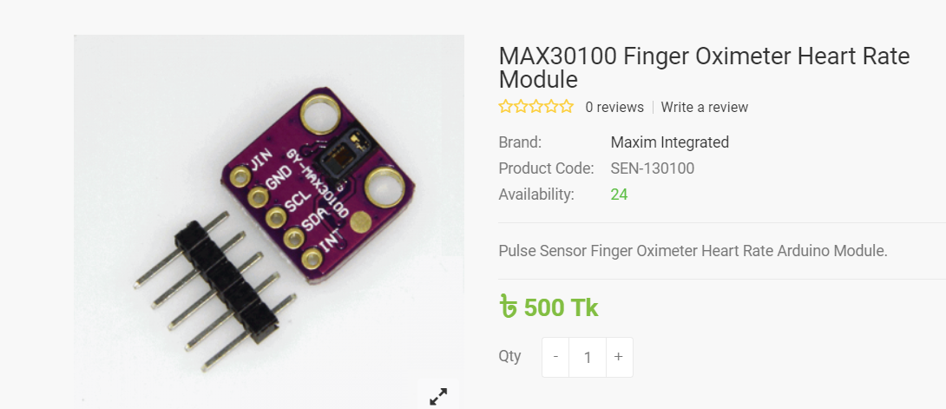

Links :

<https://bdspeedytech.com/index.php?route=product/product&product_id=2594>

<https://www.daraz.com.bd/products/gy-max30102-heart-rate-click-sensor-breakout-sensors-module-for-arduino-i145104331.html>

3. contactless temperature sensor

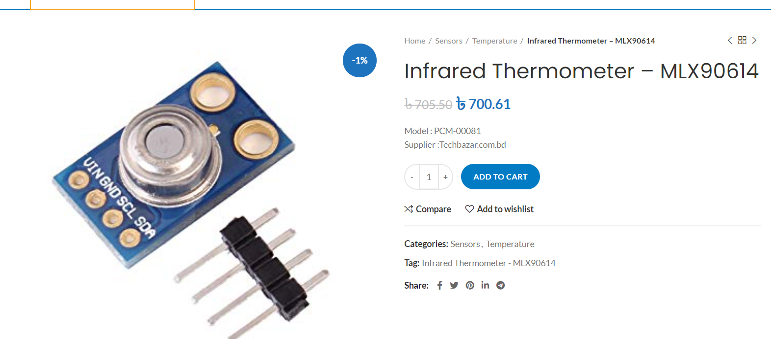

Links:

<https://www.techbazar.com.bd/product/infrared-thermometer-mlx90614-2/>

<https://www.daraz.com.bd/products/mlx90614esf-new-mlx90614-contactless-temperature-sensor-module-i122631263.html>

4.GSR sensor

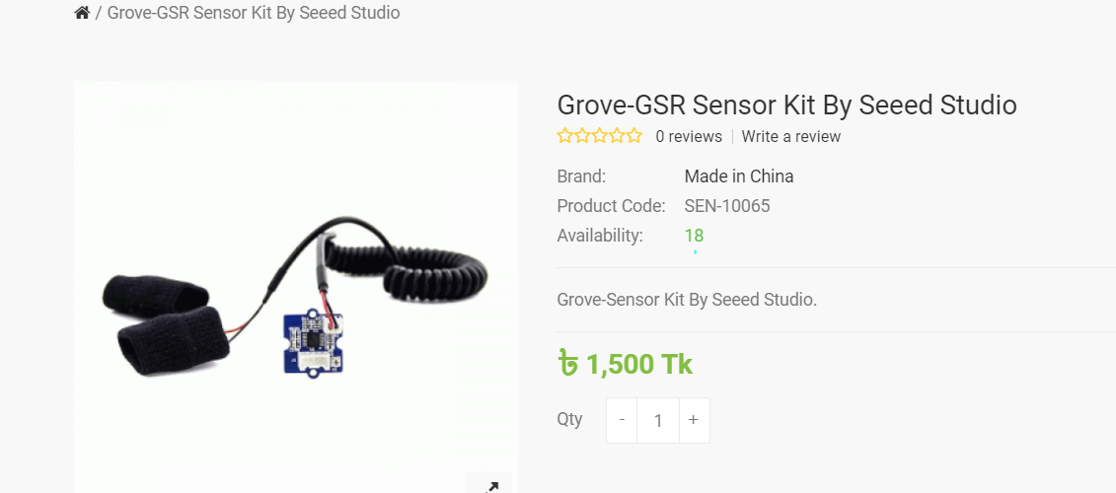

Links:

<https://bdspeedytech.com/index.php?route=product/product&product_id=3502>

**Pending:**

1.Blood pressure sensor (can be build using few companies Blood pressure machine open source available but not sure its violate copyright or not sir)

2.Blood glucose sensor (no sensor on market)

3. spirometer sensor (can be build open source available)

Alternates

1.ECG sensor

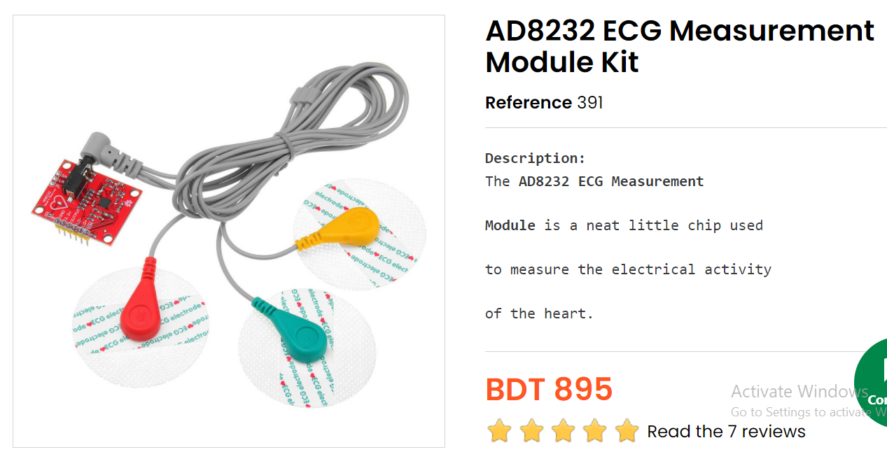

Links

<https://store.roboticsbd.com/sensors/391-ad8232-ecg-measurement-module-kit-robotics-bangladesh.html>

1.Spo2 high precisions

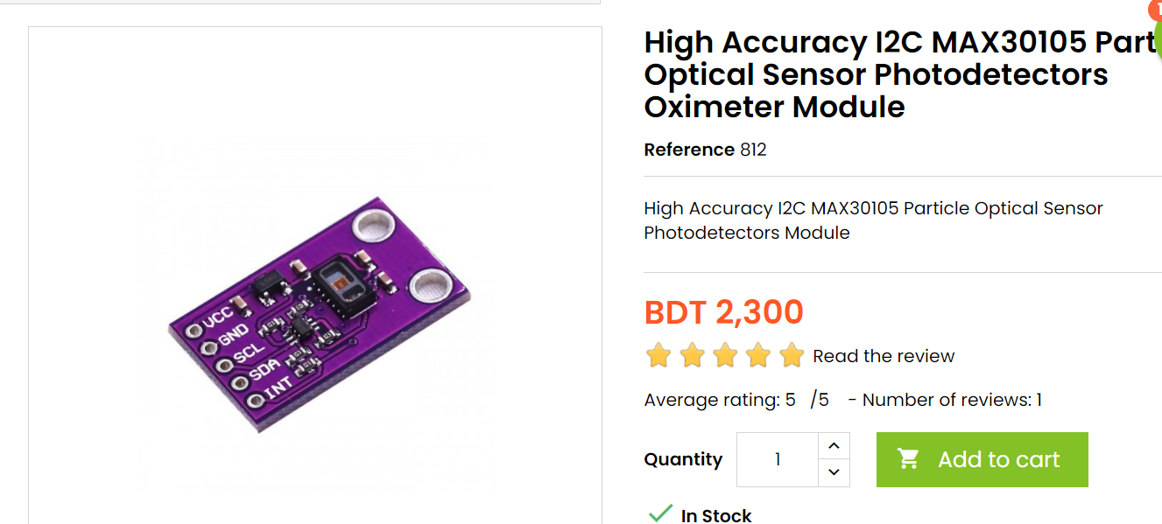

Links:

https://store.roboticsbd.com/plc-cable/812-high-accuracy-i2c-max30105-particle-optical-sensor-photodetectors-module-robotics-bangladesh.html

# 2. Heart Rate Pulse Sensor Pulse sensor Sensor Module For Arduino

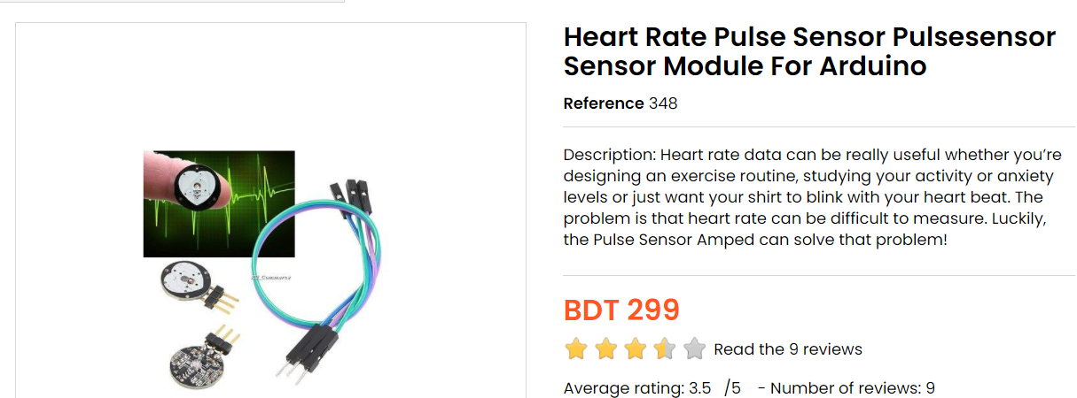

Links:

https://store.roboticsbd.com/sensors/348-heart-rate-pulse-sensor-pulsesensor-module-for-arduino.html

3.contact less Temperature sensor :

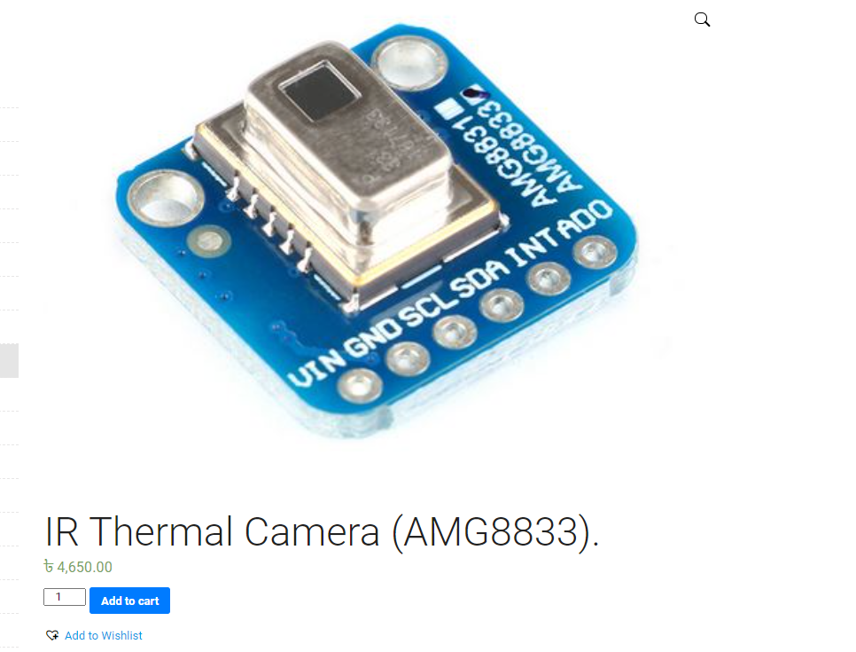

Links

<https://leetechbd.com/product/ir-thermal-camera-amg8833/>

<https://store.roboticsbd.com/temperature-humidity/1062-amg8833-ir-88-thermal-imager-array-temperature-sensor-robotics-bangladesh.html>

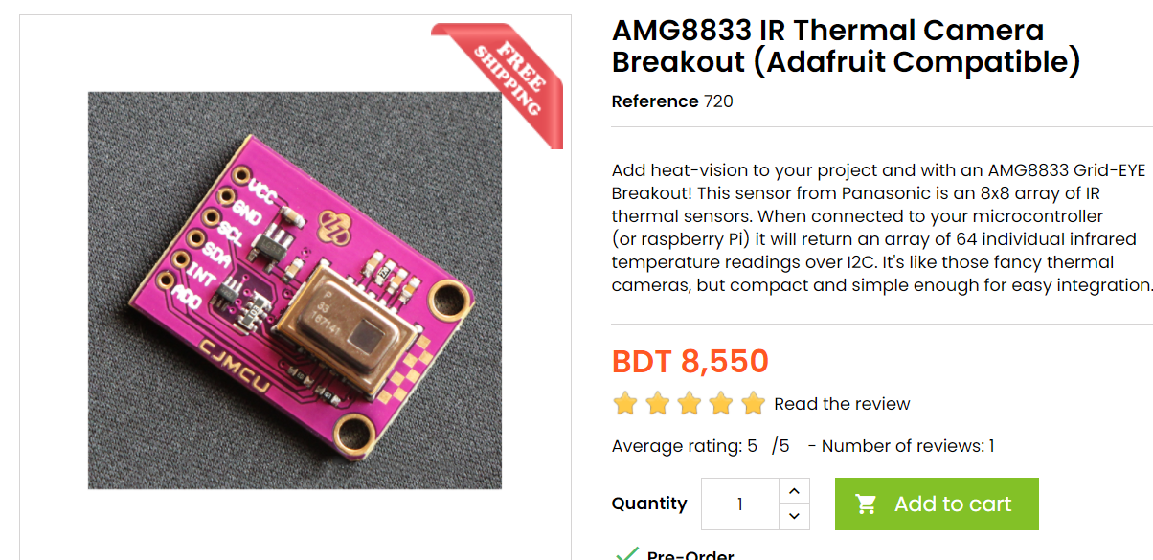

Links:

<https://store.roboticsbd.com/sensors/720-amg8833-ir-thermal-camera-breakout.html>

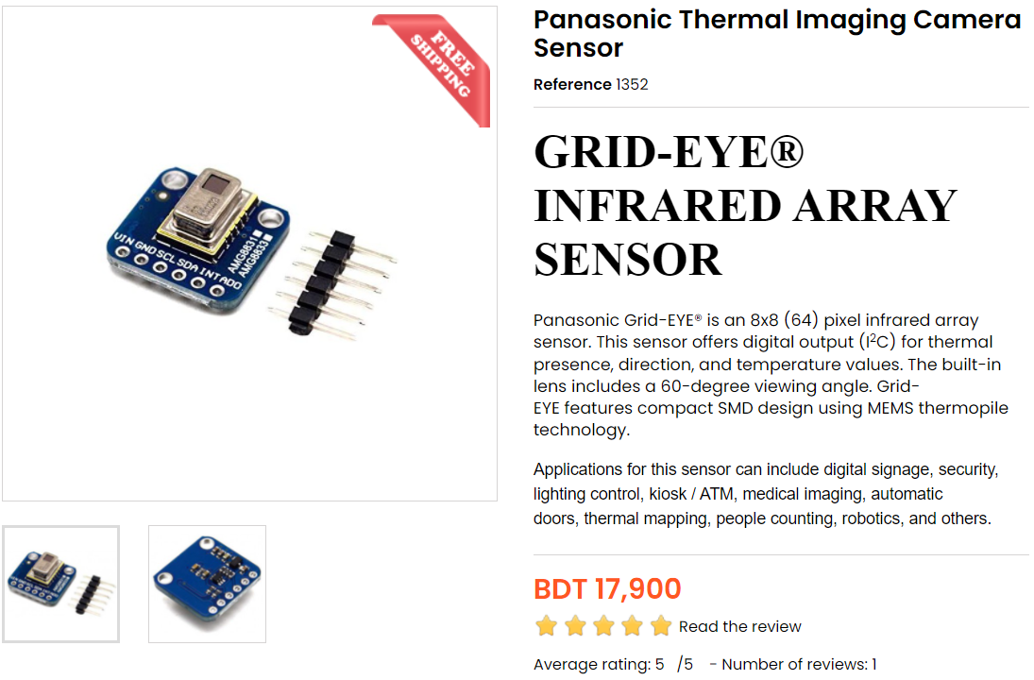

Links:

<https://store.roboticsbd.com/sensors/1352-panasonic-thermal-imaging-camera-sensor-robotics-bangladesh.html>

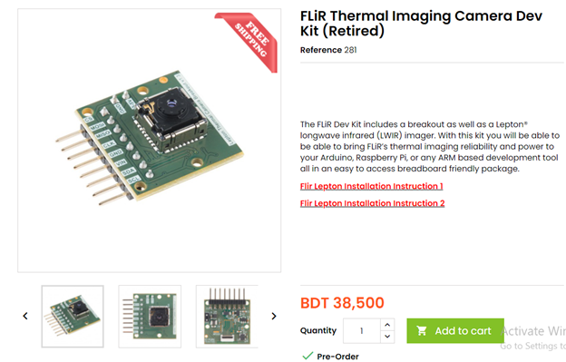

<https://store.roboticsbd.com/Legacy-Robotics-Bangladesh/281-flir-thermal-imaging-camera-dev-kit-robotics-bangladesh.html>